# Chapter 1 – Introduction

## 1.1 – Introduction to the Internship Program

As a part of the course requirement of the 8th semester of the Bachelor of Science Computer Science and Information technology (BSc CSIT) degree of Tribhuvan University, all students are required to complete a six credit (minimum 10 weeks/180 hours long) internship.

The internship experience is expected to assist the students to face complex real world problems. Going to a college or university is a critical step, but one can greatly enhance their classroom learning by gaining real world experience through college student internships. In addition to gaining great experience to complete our classroom learning, college internships allow us to beef up our portfolio or résumé and make valuable industry contacts that can be essential to landing the ideal job upon graduation.

Further, as college student internships are also competitive, one can make the most of other opportunities available to them by finding a campus job in their field. College internships are beneficial because they get us both experience and contacts.

Graduating students with paid or unpaid internships on their résumé have a much better chance at landing a full-time position upon graduation. Students are doing internships as undergraduates, and it is now not unusual for recent grads to take an unpaid internship with hopes of turning it into a permanent position or at least making some contacts and building their résumé.

## 1.2 – Objectives of Internship

The BSc. CSIT internship program is designed to develop professional skills among students and help them become familiar with the working environment. The main objectives of the internship program can be listed as follows:

* To familiarize oneself to the professional working environment
* To acquire new skills
* To build a résumé for the future
* To test the aptitude of the student for a particular career
* To understand the organization's culture and etiquette
* To gain real world perspective of an occupation
* To establish a relationship with mentors
* To have an opportunity to "test drive" a career
* To have chances to build a network with people in our area of work

## 1.3 – Introduction of the Organization

### 1.3.1 – Organizational Background

SlashPlus Pvt. Ltd. was established in December 2015 as a software firm based in Nepal with an aim to provide software development services to multifarious organizations. SlashPlus aims to foster customized software solutions to the clients by understanding the real time problems and thus providing the clients with high end software solutions. The organization emphasizes on creating an ambiance where the customers’ values are well understood and are transformed to user friendly solutions. This is well reflected by the organization's goal to 'Customize Values'.

SlashPlus has highly technical professionals and support staff. The organization also maintains a roster of software consultants and partners with a multitude of organizations with expertise in various domains. The organization is dedicated to delivering added value to the customers by providing innovative, profit-delivering software as well as technical support and expertise to help the clients achieve their business goals.

### 1.3.2 – Services Provided by the Organization

SlashPlus Pvt. Ltd. provides multiple services in the area of website design and development. The areas of expertise of the organization are:

1. Website Development
   1. Open source – Joomla, Drupal, ZenCart, Wordpress
   2. Core development – CodeIgniter, Zend
2. Software Development
   1. PHP/MySQL
   2. C#, ASP.NET
   3. Java/JSP
   4. Android
3. Database Management
   1. MySQL
   2. MsSQL Server 2005/2008
   3. Oracle 9i/10g
   4. SQLite
4. IT Consulting
   1. Network Consulting
   2. Web Consulting
   3. Software Consulting

### 1.3.4 – Organization Composition

SlashPlush Pvt. Ltd. comprises of an administrative team along with interns, junior and senior programmers and web designers.

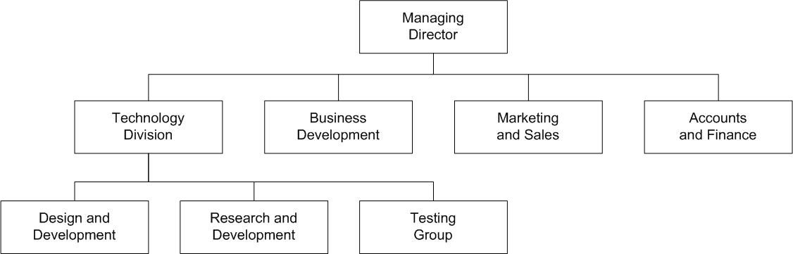

Figure 1.1 – Organizational Chart

### 1.3.5 – Contact Details

Table 1 Contact Details of the Organization

|  |  |
| --- | --- |
| Location: | Kumaripati , Lalitpur, Nepal |
| Opening Hours: | 7 AM to 7 PM |
| Contact No.: | 01-5521274 |
| Email Address: | [mail@slashplush.com.np](mailto:mail@slashplush.com.np) |
| Website: | <http://www.slashplush.com.np> |

## 1.4 – Scope and Limitations of the Report

### 1.4.1 – Scope

This report consists of the details of the work that I performed during my internship period in SlashPlush Pvt. Ltd. During the internship period, the major project that I worked on was Online Taxi Application and this report mentions the system analysis and design of this project, how it is implemented and some of the testing mechanisms. The report also discusses the knowledge I gained during my time in the organization.

### 1.4.2 – Limitations

There are some limitations of this internship report. They are listed as follows:

* Each and every part of the functioning of the organization has not been described as there are restrictions due the privacy policies of the organization.
* Economic details of the project have not been mentioned due to confidentiality issues.

# Chapter 2 – Placement and Analysis of the Activities Performed

## 2.1 – Internship Placement

### 2.1.1 – Organization Selection and Placement

As the part of the internship course requirement of the BSc. CSIT syllabus, students were required to select organizations that perform project implementation or research from the following domain:

* Banks
* Hospitals
* Software Companies
* Organizations in the Telecommunications Sector (NTC, NCell, etc.)
* IT Related Government Organizations

I dropped my CV at different organizations through their official email addresses. Among those organizations, I was recommended to SlashPlush Pvt. Ltd. by my college's administration team. Some of the organizations responded and invited me for an interview. Finally, I was selected for the position of an intern programmer at SlashPlush Pvt. Ltd.

After I was selected, I was placed in the organization as an intern programmer. I started working in the Android programming. The programming was done using Android Studio 2.2.3. Initially, I wrote programming codes on small parts of the ongoing projects of the organization. After some time, I started working on the project Online Taxi Application.

### 2.2.2 – Internship Period Details

I worked for a total of 3 months as an intern at SlashPlush Pvt. Ltd. The details of my internship period in the organization are summarized in the following table:

Table 2 Internship Period Details

|  |  |
| --- | --- |
| Internship Start Date: | 6th November, 2016 |
| Internship End Date: | 24th , Janaury,2017 |
| Office Hour: | 10 AM to 6 PM |
| Working Days: | Sunday to Friday |
| Position: | Intern Programmer |
| Supervisor: | Jagat Rauniyar |

## 2.3 – Online Taxi Application Project

Online Taxi Application is a android based application that is used to facilitate the taxi users in Kathmandu valley. The Online Taxi Application is also used to order taxis online within Kathmandu valley.

After I was chosen as a programmer for developing the Online Taxi Application project, my key responsibility was to develop separate modules which include models, views and controllers for each different function of the application. The client had provided us with an initial database containing various entries with details of people to be used in the application.

As a programmer, I performed the following tasks on the Online Taxi Application:

1. Develop modules for back-end and front-end interfaces. They performed following functionalities:
   * Adding new passengers and editing their information
   * Specifying and tracking passengers place and destination place
   * Updating the taxi fares
2. Assist other programmers to add search functions in the application.
3. Give assistance to create customized reports in the application.
4. Give suggestions about new features that could be added in the application and about how the codes could be optimized.

## 2.4 – Project Management Strategies Used for Online Taxi Application

Project management is the discipline of initiating, planning, executing, controlling, and closing the work of a team to achieve specific goals and meet specific success criteria. A project is a temporary endeavor designed to produce a unique product, service or result with a defined beginning and end (usually time-constrained, and often constrained by funding or deliverables) undertaken to meet unique goals and objectives, typically to bring about beneficial change or added value .

The primary challenge of project management is to achieve all of the project goals and constraints. This information is usually described in a user or project manual, which is created at the beginning of the development. The primary constraints contain many things. The secondary — and more ambitious — challenge is to optimize the allocation of necessary inputs and integrate them to meet pre-defined objectives.

# Chapter 3 – Data Collection and System Analysis

## 3.1 – Data Collection

Data collection is the process of gathering and measuring information on targeted variables in an established systematic fashion, which then enables one to answer relevant questions and evaluate outcomes. The data collection component of research is common to all fields of study including physical and social sciences, humanities and business. While methods vary by discipline, the emphasis on ensuring accurate and honest collection remains the same. The goal for all data collection is to capture quality evidence that then translates to rich data analysis and allows the building of a convincing and credible answer to questions that have been posed.

## 3.2 – System Analysis

System analysis is a general methodology (not a fixed set of techniques) that applies a 'systems' perspective by taking all aspects of the situation into account, and by concentrating on the interactions between its different elements. It provides a framework in which judgments of the experts in different fields can be combined to determine what must be done, and what is the best way to accomplish it in light of current and future needs.

Systems analysis is the process of studying a procedure or business in order to identify its goals and purposes and create systems and procedures that will achieve them in an efficient way.

### 3.2.1 – Feasibility Analysis

Feasibility analysis is an assessment of the practicality of a proposed project. Feasibility analysis aims to objectively and rationally uncover the strengths and weaknesses of an existing business or proposed venture, opportunities and threats present in the environment, the resources required to carry through, and ultimately the prospects for success. In its simplest terms, the two criteria to judge feasibility are cost required and value to be attained.

The feasibility analysis was conducted in the following areas of the Online Taxi Application project:

**(a) Technical Feasibility**

The technical feasibility assessment is focused on gaining an understanding of the present technical resources of the organization and their applicability to the expected needs of the proposed system. It is an evaluation of the hardware and software and how it meets the need of the proposed system. This assessment is based on an outline design of system requirements, to determine whether the company has the technical expertise to handle completion of the project.

The Online Taxi Application was developed to be used as a android application with an aim to facilitate the taxi users in Kathmandu valley.

The technical requirement for the development of this application was minimal with programmers requiring computer systems (laptops or desktops) that could support the following features:

* Support for Android Studio 2.2.3
* Support for MySQL/SQLite DBMS
* Support for server applications like XAMPP or WampServer

**(b) Economic Feasibility**

The purpose of the economic feasibility assessment is to determine the positive economic benefits to the organization that the proposed system will provide. It includes quantification and identification of all the benefits expected. This assessment typically involves a cost/ benefits analysis.

The administration team of the organization carried out a cost-benefit analysis after the undertaking of the project. The result of the analysis proved to be positive since the benefits of the project was higher than the cost. The project development budget was also considered feasible. Thus, the project was concluded to be economically feasible.

**(c) Operational Feasibility**

Operational feasibility is a measure of how well a proposed system solves the problems, and takes advantage of the opportunities identified during scope definition and how it satisfies the requirements identified in the requirements analysis phase of system development. The operational feasibility assessment focuses on the degree to which the proposed development projects fits in with the existing business environment and objectives.

The Online Taxi Application that was planned to be developed would have functionalities of adding information about new passengers, recording their places and destination places, finalizing their taxi fares, etc and so on. These functionalities of the proposed application covered the entire requirement domain of the client. Since the proposed application would fulfill all of the client's requirements, it was concluded to be operationally feasible.

**(d) Legal Feasibility**

Legal feasibility assessment determines whether the proposed system conflicts with legal requirements; for instance, a data processing system must comply with the local data protection regulations.

The development of this project used methodologies acceptable within the cyber laws of Nepal. The client approved its development and provided employee records that were collected legally with the consent of the participating governmental organization and their corresponding departments. Hence, the project was legally feasible.

**(e) Schedule Feasibility**

Schedule feasibility is a measure of how reasonable the project timetable is. A project will fail if it takes too long to be completed before it is useful. Typically this means estimating how long the system will take to develop, and if it can be completed in a given time period using some methods like payback period.

The client provided a timeline for the entire project to be completed. The project team of the organization divided this time into analysis and design phase, development phase and testing phase. It was concluded after this phenomenon that the project could be completed within the given timeline taking into account the available resources. So, the project was deemed feasible in terms of schedule.

# Chapter 4 – System Design

Systems design is the process of defining the architecture, components, modules, interfaces, and data for a system to satisfy specified requirements. Systems design could be seen as the application of systems theory to product development.

## 4.1 – Use Case Diagram

A use case diagram at its simplest is a representation of a user's interaction with the system that shows the relationship between the user and the different use cases in which the user is involved. A use case diagram can identify the different types of users of a system and the different use cases and will often be accompanied by other types of diagrams as well.

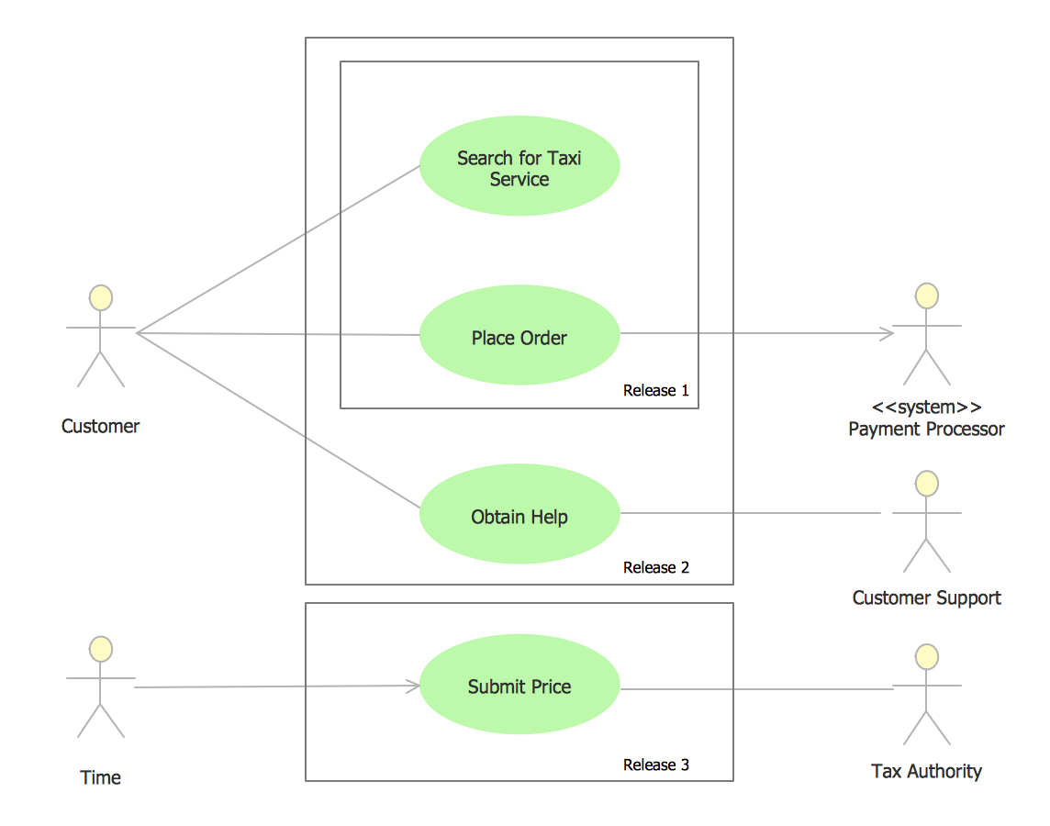

Fig: Use case diagram of Online Taxi Application

# Chapter 5 – Implementation and Testing

## 5.1 – Implementation Tools

For the implementation of the Online Taxi Application, the following tools were used:

Table 3 Tools Used

|  |  |
| --- | --- |
| UML Tools | DFD, Use Case Diagram, Context Diagram |
| Operating System | Microsoft Windows 7 |
| Database | MySQL ,SQLite |
| Programming Language | Android |
| Server | WampServer/ XAMPP |
| IDE | Android Studio 2.2.3 |

## 5.2 – Testing Strategies

Software testing is an investigation conducted to provide stakeholders with information about the quality of the product or service under test. Software testing can also provide an objective, independent view of the software to allow the business to appreciate and understand the risks of software implementation. Test techniques include the process of executing a program or application with the intent of finding software bugs (errors or other defects).

The following testing strategies were applied for the Online Taxi Application:

### 5.2.1 – Unit Testing

Unit testing is a software testing method by which individual units of source code, sets of one or more computer program modules together with associated control data, usage procedures, and operating procedures, are tested to determine whether they are fit for use. Intuitively, one can view a unit as the smallest testable part of an application.

In this testing, each test case is independent from the others. Unit tests are typically written and run by software developers to ensure that code meets its design and behaves as intended.

The following table summarizes some of the unit tests conducted in the application:

Table 4 Unit Tests on the Application

|  |  |  |  |
| --- | --- | --- | --- |
| S.No. | Test Objective | Test Condition | Expected Result |
| 1 | Login into the application | The username and password entered by the user is checked | If the login is successful, a session is created and the user is redirected to the index page |
| 2 | Logout from the application | User logs out from the application | The session is destroyed and the user is redirected to the login page |
| 3 | Data insertion from the view of a certain module | The user enters data using different forms | The data entered by the user is inserted into the appropriate tables in the database |
| 4 | Data search | The user searches the record by selecting conditions through the given dropdown menus | If the records corresponding to the given search conditions exist in the database, the results are displayed in a tabular format |

### 5.2.2 – Integration Testing

Integration testing (sometimes called integration and testing) is the phase in software testing in which individual software modules are combined and tested as a group. It occurs after unit testing and before validation testing. Integration testing takes as its input modules that have been unit tested, groups them in larger aggregates, applies tests defined in an integration test plan to those aggregates, and delivers as its output the integrated system ready for system testing.

Since the development of the Online Taxi Application involved multiple programmers, different modules were coded by different programmers. Different parts of the applications had different deadlines and within each deadline, some deliverables had to be ready. Thus, for each deliverable, modules from different programmers were integrated and tested for bugs.

### 5.2.5 – System Testing

System testing of software or hardware is testing conducted on a complete, integrated system to evaluate the system's compliance with its specified requirements. System testing falls within the scope of black-box testing, and as such, should require no knowledge of the inner design of the code or logic.

As a rule, system testing takes, as its input, all of the "integrated" software components that have passed integration testing and also the software system itself integrated with any applicable hardware system(s). System testing is performed on the entire system in the context of a Functional Requirement Specification(s) (FRS) and/or a System Requirement Specification (SRS).

At the end of the development, the entire Online Taxi Application was tested for bugs and possible errors. The system was compiled and run to check if errors existed. The errors that existed were properly handled.

# Chapter 6 – Conclusion and Recommendations for Enhancement

## 6.1 – Limitations of the System / Future Enhancements

In software companies, applications or systems are developed according to the requirements of the clients and with the motto that "Clients are always right". Similarly, the Online Taxi Application was also developed according to the requirements of the client. But, there were areas with limitations which could be enhanced in the future. They are listed below:

1. The system is not compatible with IOS .The system could be developed in iOS in the future.
2. For using the application, internet access is compulsory. There is no facility of offline services.
3. The application does not provide a guide as to how to enter data in the forms.

## 6.2 – Conclusion

Working as an intern at SlashPlush Pvt. Ltd. was a great experience for me. This was my first crack at working in a professional environment. Before being involved as an intern in the organization, I only had an outside view and an insight as an observer as to how a professional organization functioned. But after completion of my internship, I got an inside view of professional surroundings and gained experience by being involved in the day-to-day activities directly. The IT industry is one of the leading industries in Nepal today. The internship program helped me learn about the growth of this industry and gain further knowledge about it.

Working at SlashPlush also helped me broaden my technical knowledge in the programming field. I only had basic knowledge about Android programming language before my involvement as an intern. During my stay in the organization, I also got to broaden my knowledge about Android. I also learnt some basic AJAX functionalities.

Overall, the internship program helped me develop skills such as handling real-world problems, working under the rules and regulations of an organization, working under a deadline and working under pressure. It helped me gain technical knowledge as well as professional experience which will be very helpful throughout my professional career.

# REFERENCES

[1] "Why are internships so important?", Beth Braccio Hering, CareerBuilder.com, April 14, 2010

[2] "HMVC: The layered pattern for developing strong client tiers", Jason Cai, Ranjit Kapila and Gaurav Pal, JavaWorld, July 21, 2000

[4] "Beginning Ajax", Chris Ullman, March 2007

[5] "The Definitive Guide to Project Management", Sebastian Nokes, 2nd Edition London (Financial Times / Prentice Hall), 2007

[6] "The feasibility study as a tool for venture analysis", R. T. Justis & B. Kreigsmann, Business Journal of Small Business Management, 1979

[8] "Exploratory Testing" , Cem Kaner, Florida Institute of Technology, Quality Assurance Institute Worldwide Annual Software Testing Conference, Orlando, FL, November 17, 2006

# APPENDIX

Below are some sample screenshots of the application:

(1) Login screen of Online Taxi Application

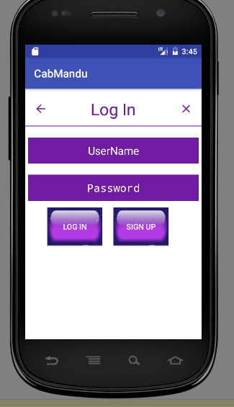

FigureLogin Form Of OTA

(2) Sign Up Form For Admin

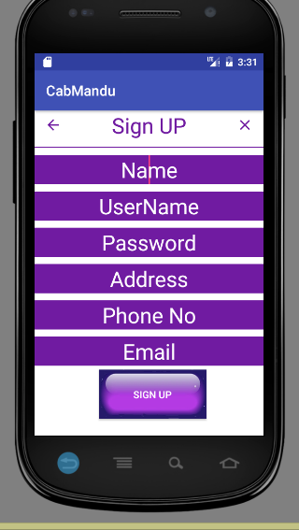

Figure Sign Up For Admin

(3) Detailed View of a Customer

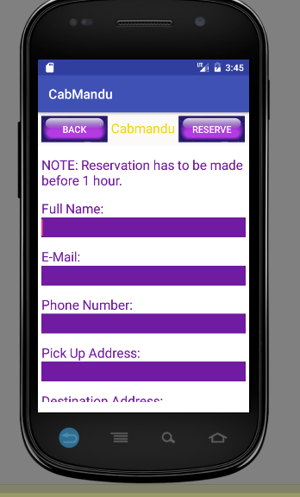

Figure Detail For Customer

4) Main Page Of Online Taxi Application

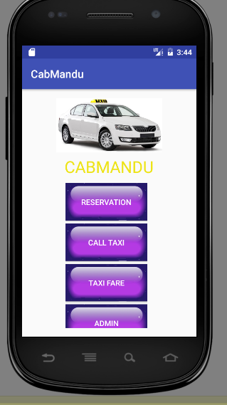

Figure Main Page Of OTA